**Add Lists to Blog Page**

**Send Feedback**

As of now our basic template containing all the content is ready. But it does not look right, does it? So, what can we do?

The headings after the 'Prerequisites' are all inside it. So it would be better to provide it as a list on the page.

I think now you know what to do. So, let's get started and provide the headings after the 'Prerequisites' as an unordered list on the page.

**Expected blog page is -**

[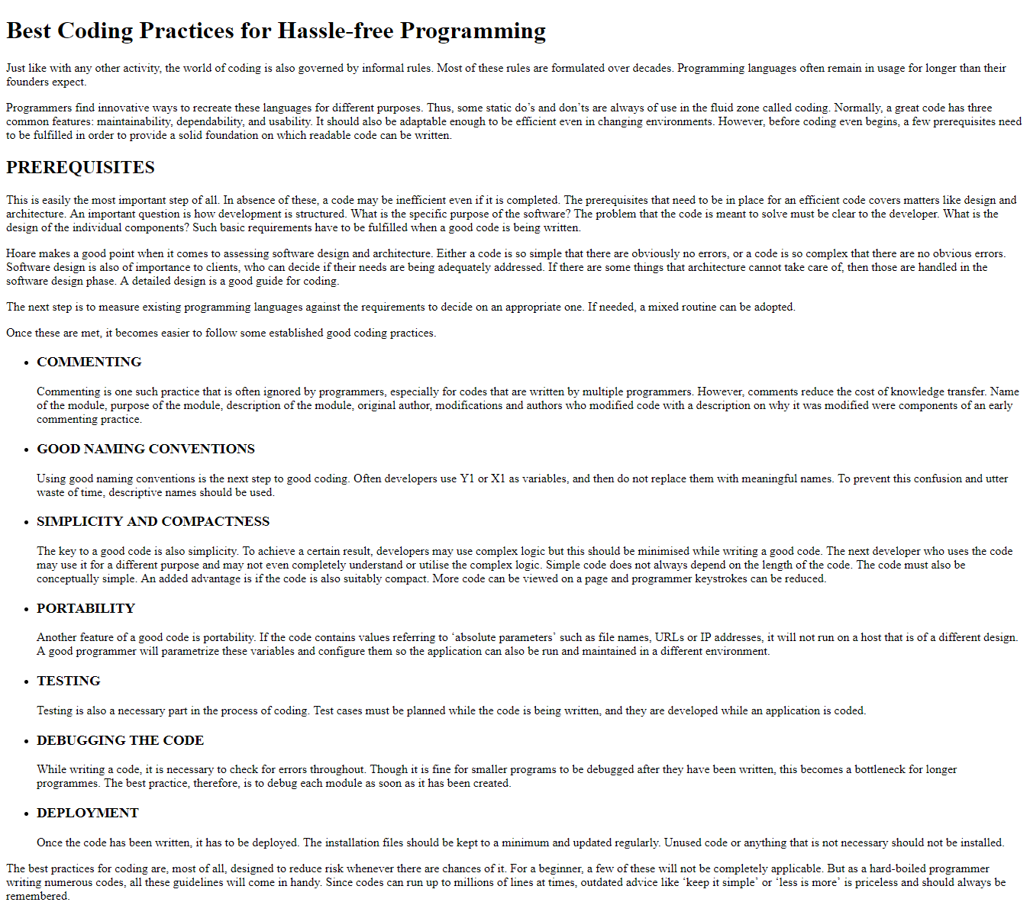](https://ninjasfiles.s3.amazonaws.com/0000000000001391.png)